Khan's log
Star date 1/1/15
Happy New Year! With the start of the new year we now have a little more than two weeks until our first competition in Paris Lake, CA. With the competition approaching we are moving towards driver practice and software work. With the first few rounds of driver practice we have noticed some wear on the robots 3D printed parts. The motor screws on the nacelles have begun to wear away at the plastic underneath them and one of the plastic brackets that holds the cross spars and the rails together has sheered in half. Luckily we have a spare bracket but after the shattered nacelle incident earlier this year we have no spare nacelles. We are currently working to make a request to NASA Armstrong to have a new set of parts printed. Also we have found that our wiring system is a bit too compact for some of the team members to use so we are working on rearranging the motor controllers within the cross spares.

Khan's log
Star date 1/8/15
Tonight is a night for final touches and fixes as well as driver practice and judging practice. One fix that was made was the implementation of fillers in the nacelles. They are made of a 1" aluminum rectangular tubes that are inserted into the nacelles to give them stiffness.
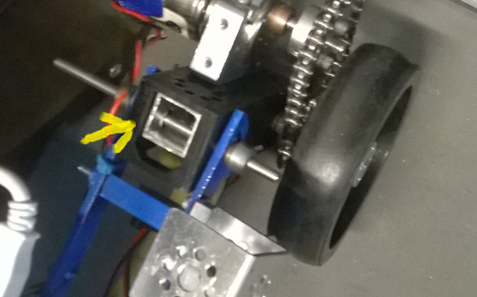
We have also noticed that the drawer slides hit the back right motor when they come back down. To fix this anomaly we are utilizing the modular nature of the KR4 chassis. The Brackets can be unscrewed from the rails and the whole center of the robot can be slid forward on the rails to make space for the slides.

For the remaining two days we will continue driver practice and autonomy writing. The robot needs servo hooks remounted on the back of the robot. PERRIS HERE WE COME!

